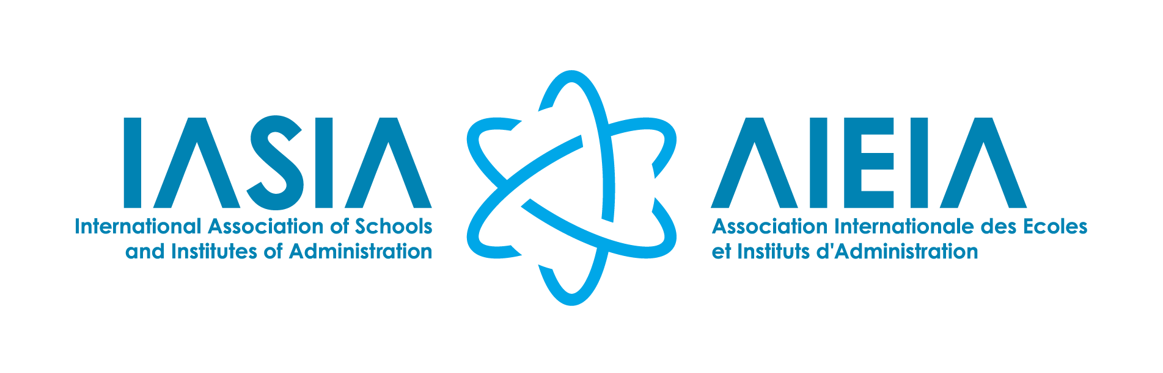

IASIA WORKING GROUPS

CALL FOR PROPOSALS

PRESIDENTIAL COMMUNIQUÉ

Dear Members of the IASIA Community,

The International Association of Schools and Institutes of Administration (IASIA), as part of the International Institute of Administrative Sciences (IIAS), brings together a network of 130 institutional members across 56 countries. With a global governance agenda, IASIA advances public administration and public service through high-impact events that engage institutions, academia, and practitioners worldwide.

At the heart of IASIA are its permanent Working Groups (WGs). These groups embody the spirit and core mission of IASIA, serving as the foundation for shaping the Annual Conferences held worldwide. WGs play a pivotal role in ensuring that each conference is relevant, content-rich, and impactful, driving participation, expanding the network, and strengthening the IASIA community.

In light of the evolving landscape of Public Administration and Management, IASIA is reviewing its Working Group structure to ensure it remains relevant and responsive to developments in the field. This process will encompass both existing and prospective Working Groups. Accordingly, all current Working Groups will be required to submit a proposal for renewed consideration under the revised structure.

We therefore invite active IASIA members to submit proposals for new Working Groups and for the continuation or revision of existing Working Groups, as well as expressions of interest in leadership positions within the Working Groups. This process provides an opportunity to draw on the expertise and perspectives of our members in shaping the future direction of IASIA’s scientific activities.

Submissions should be received by 6 October 2026 at 5:00 PM Brussels time. All proposals will be reviewed anonymously by the IASIA Working Group Committee and the IASIA Steering Committee on 12 October 2026. (Please use the WORD format. This will allow the secretariat to remove names for the review process). Following this review, a proposal will be presented to the IASIA Board of Management for consideration. Depending on the number of applications received, the timeframe for final decisions may be adjusted.

We warmly encourage the IASIA fraternity to participate in this process and look forward to receiving your proposals and expressions of interest.

With warm regards,

Prof. Dr Liezel Lues
President
International Association of Schools and Institutes of Administration (IASIA)
10 September 2026
CALL FOR PROPOSALS
As part of the review of the IASIA Working Group structure, members are invited to submit:
- new Working Groups and for the continuation or revision of existing Working Groups, as well as
- expressions of interest in leadership positions within the Working Groups.

CURRENT IASIA WORKING GROUPS
For reference, the current Working Groups are:
I. Education and Training in Public Administration
II. Ethics and Culture in the Public Sector
III. Public Sector Reform
IV. Subnational Governance and Development
V. Gender, Diversity and Equity
VI. Public Sector Governance, Leadership and Management
VII. Public Policy, Decision-making and Policy Implementation
VIII. Human Resources Management in the Public Sector
IX. International Dimensions of Public Administration
X. Public Administration in Fragile and Conflict-affected States
XI. Disaster Risk Reduction and Resilience
XII. AI and Emerging Technology

ROLE, RESPONSIBILITY, AND COMMITMENTS OF WG PROJECT DIRECTORS AND CO-CHAIRS
The working group project director takes the lead in managing all activities. The co-chairs function in a supportive capacity.
- Maintain a high level of expertise in the academic domain relevant to the Working Group.
- Undertake rigorous research and disseminate findings through publications aligned with the Working Group’s focus area.
- Regularly develop and update the WG’s objectives and themes.
- Prepare calls for papers and rationales for WG sessions at the annual Conference.
- Promote WG activities through e-mail, social media, and personal networks.
- Mobilise members and networks to submit abstracts, papers, and contributions.
- Recruit new members to join the IASIA Network.
- Evaluate submissions and arrange presentations for the annual Conference programme.
- Attend and actively participate in the annual IASIA Conference, including chairing WG sessions.
- Submit and present feedback reports at the Conference closing session.
- Propose and coordinate publication initiatives for journals and the IASIA book series.
- Nominate outstanding WG papers for the Best Conference Paper Award.
- Provide information reports for the IASIA Community.
- Represent the WG in international forums and contribute to activities organized by IASIA, IIAS, and their partners.

Eligibility and Commitments for WG Co-Chairs and Project Directors
- Demonstrated academic leadership, scholarly expertise, or professional practice in the field of the Working Group, evidenced by relevant research outputs and publications.
- Formal affiliation with IASIA, either through an institutional membership or as an individual member.

Candidate Selection Criteria
In appointing candidates to vacant positions, IASIA will consider:
- Ensuring gender balance within the Working Group.
- Promoting regional collaboration across the Working Group.
- Limiting membership to one Working Group per applicant.
- Demonstrated expertise in the proposed focus of the Working Group.
- A firm commitment to attend IASIA Conferences.

Timeline
- February 2026: Appointment of the Working Group Committee
- March 2026: Online meeting of the Working Group Committee and 1st draft proposal
- April 2026: Informing the IASIA BoM
- June 2026: Discussions with the IASIA Steering Committee
- July 2026: Online meeting with the current IASIA WG directors and chairs
- September 2026: Send out call for WG to all current IASIA member institutions
- 6 October 2026: Closing date
- 12 October 2026: Face-to-face workshop revisiting all the submissions received (reviewed anonymously by the IASIA Working Group Committee and the IASIA Steering Committee)
- The Steering Committee present the proposals to the IASIA BoM
- November: Announce the IASIA working groups / Meeting with working group leaders and co-chairs
- 2027: Call for the 2027 conference papers.

TEMPLATE FOR GROUP SUBMISSIONS

- Title of the Working Group – a concise and descriptive name
- Rationale – a clear explanation of the proposed title, its relevance to Public Administration and Management, and its alignment with IASIA’s mission (200 words)
- Aim
- Proposed Activities – suggested outputs, events, or contributions to IASIA conferences (200 words)
- Proposed WG director | Title, Name & surname | Gender | Country
Bio (200 words)
 | Signature: | Date:
- Proposed WG chair 1 | Title, Name & surname | Gender | Country
Bio (200 words)
 | Signature: | Date:
- Proposed WG chair 2 | Title, Name & surname | Gender | Country
Bio (200 words)
 | Signature: | Date:

TEMPLATE FOR INDIVIDUAL SUBMISSIONS

- Title of the Working Group – a concise and descriptive name
- Rationale – a clear explanation of the proposed title, its relevance to Public Administration and Management, and its alignment with IASIA’s mission (200 words)
- Aim
- Proposed Activities – suggested outputs, events, or contributions to IASIA conferences (200 words)
 | Title, Name & surname | Gender | Country
Bio (200 words)
 | Signature: | Date:

You are invited to send the following documents, in WORD format, to the IASIA Executive Secretary, Diana Muia d.muia@iias-iisa.org by 6 October 2026 (5.00 pm Brussels time).

